J.Pritchard U1661665

U1661665@unimail.hud.ac.uk

Logbook

Algorithms – Processes and data

# Practical 13 (Week 17)

## (Logbook) What is the matrix for the following circuit?

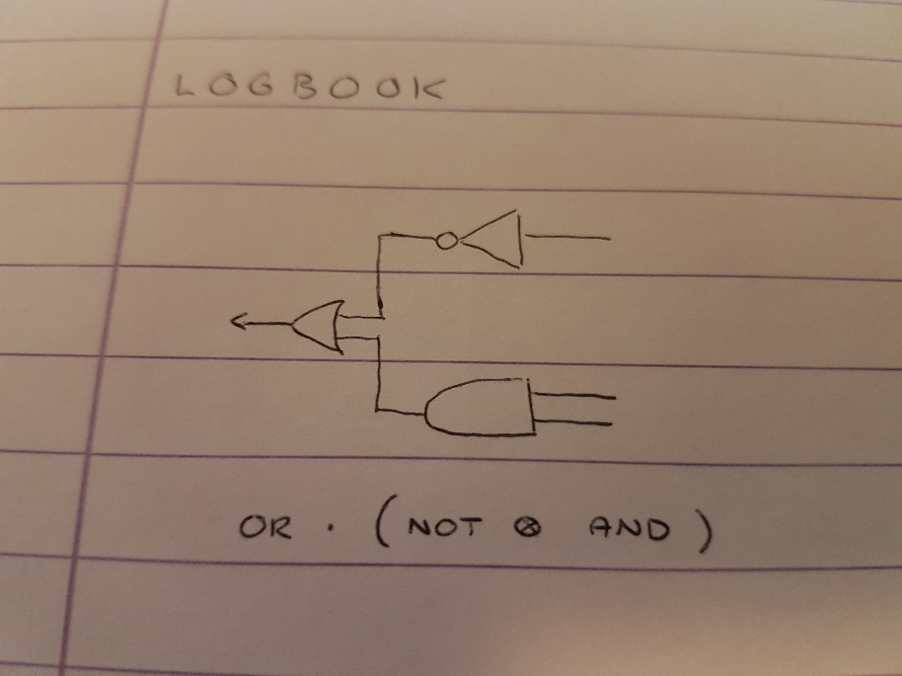

The Logbook is made of a parallel circuit of a NOT & AND, followed by a sequential OR. This is shown by the equation below the diagram.

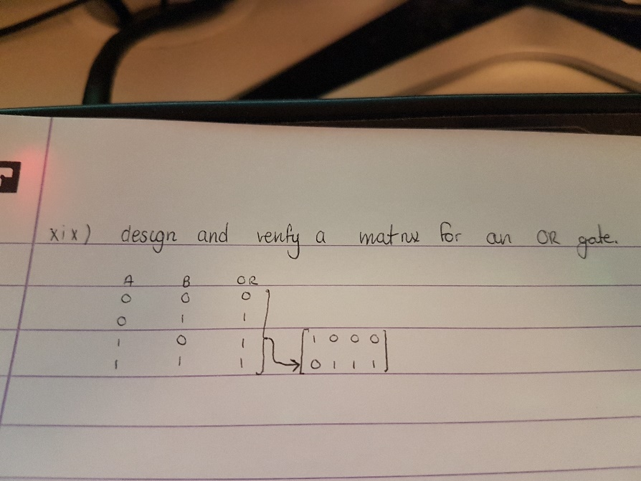

I was asked previously to design a matrix for an OR gate.

This consists of taking the truth table values for a regular OR gate, putting them top to bottom/left to right, then substituting the values for their individual bit sequence matrices. (1 = [0;1], 0 = [1;0]).

NOTE: the ordering of the 0 and 1 values in the truth table derivation is sensitive here. This must be done in the correct way (as shown) for the resulting matrix to be a correct representation of the gate.

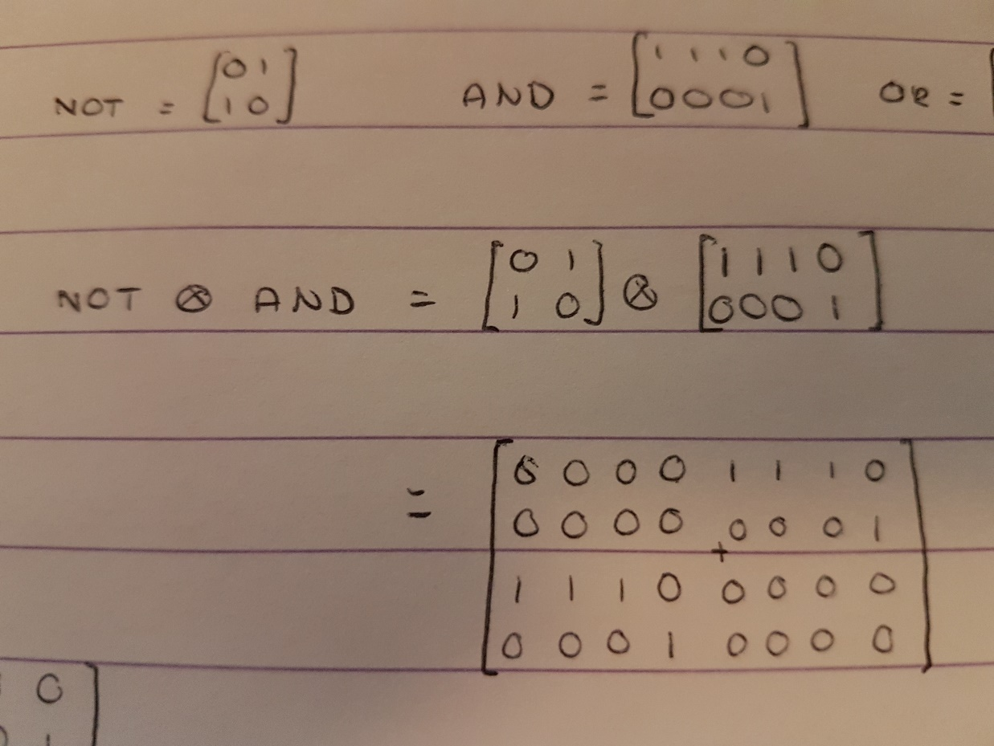

The first step to calculating the matrix for the entire circuit is calculating the parallel component first. This is done by calculating the tensor product of the two gates. Tensor product is calculating the scalar product of each element of matrix A with the entirety of matrix B.

This results in the matrix calculated in the picture.

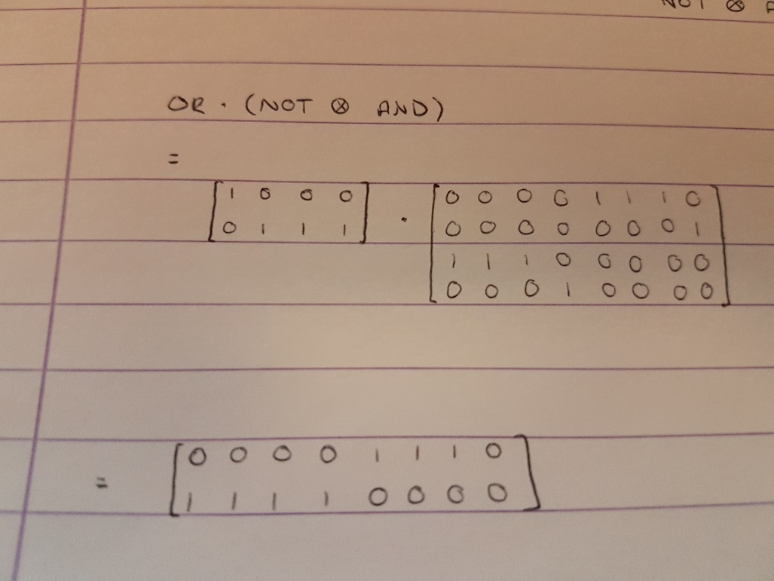

The result of the previous calculation (NOT ⊗ AND) can then be applied to the sequential OR gate by simply multiplying the two matrices. This results in the complete gate for the circuit.